***Experiment.5 – Design a smartphone controlled light system.***

Concept used:-

1. This experiment is the pure blend of the Bluetooth, smartphone and the main concept used is LED FLASHER.
2. 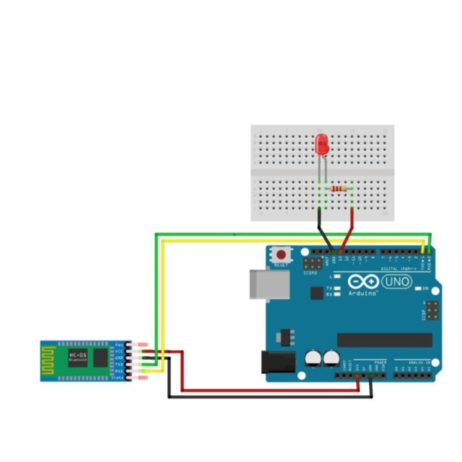In this experiment we used a Bluetooth IC to flash the LED in Breadboard to glow .
3. Concept used in this experiment is how the Bluetooth IC is to be connected to the Arduino so that signals can easily transferred and received .
4. A circuit is made using Bluetooth and Arduino .tx of Bluetooth is connect to 0 of arduino .
5. Ground of Bluetooth is connected to the ground of Arduino. And VCC (high voltage)is connected 5V of Arduino.

**Learning and observations:-**

1. Connection need to be made to execute the experiment.
2. Concept of understanding transfer and receiver .
3. Ground of bluetooth is connected to the ground of arduino.
4. Signals are transmitted from Bluetooth to arduino.
5. Bluetooth receive the signal by Rx(0) an abbreviation used for receiver.
6. Coding to be done on Arduino.exe for the stimulation of the program.

**Problems and Troubleshooting:-**

* Minors errors showed up in the code during the test run,which was trouble shooted by the correct ing.
* Making a functional was a bit time taking as it becomes a bit confusing on arranging the wires .

**Precautions:-**

* Connection of the Tx and Rx pins respectively.
* Use of multimeter for checking whether the device is working or not.
* Port selection for Arduino can be incorrect due to which it won’t work.

**Learning outcomes:-**

* Making connection of Bluetooth and Arduino board .
* Connecting Bluetooth and arduino.
* Working and coding of arduino.